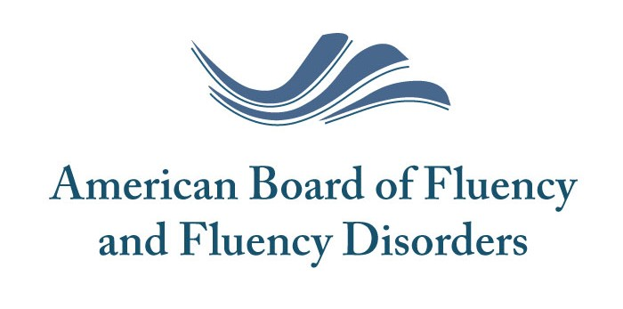
Board Certified Specialist --- Fluency
Retired OR Life-Time Member Application
Name:
Address:
City: | State: | Zip:
Phone: ( ) | Email:
Fax: ( ) | Date of Application:
Please check the following if correct:  ◻ I am currently a BCS-­‐F  OR  ◻ I was a BCS-­‐F (BRS-­‐FD) at the  time of my retirement  _______________________  ◻ I was a BCS-­‐F (BRS-­‐FD) for at least ten years (not necessarily consecutive)  ◻ I am 65 years of age or older  OR  ◻ I have been an ASHA Certified Member for at least 25 years  Please check one:  ◻ Please list me as Life-Time (I am currently treating clients and maintain my ASHA CCCs).**  ◻ Please list me as Retired (I am no longer treating clients and do not currently have my ASHA CCCs). | Please verify you have enclosed the  following with this form:  ◻ I have enclosed a copy of my driver’s license or birth certificate  OR  ◻ I have provided documentation confirming my ASHA Certification for at least 25 years  ____________________________________  ◻ I have enclosed a check payable  to the ABFFD for $75.00  (US Dollars)  **Please note: you must continue to maintain the same status with ASHA to maintain the same member status with the ABFFD.**
563 Carter Court, Suite B, Kimberly, WI 54136
Email: info@stutteringspecialists.org

