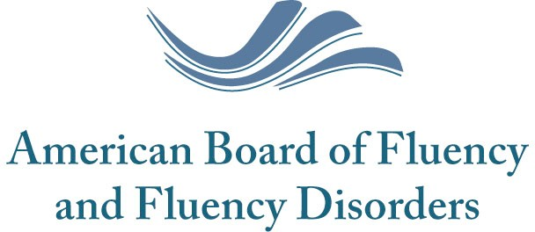

Board Certified Specialist-­‐Fluency Application
Verification of Direct Clinical Activity Form

**Form to be filled out by the applicant’s supervisor or the applicant himself/herself, in the case of a private practice.

To Whom it May Concern:

You have been asked by the applicant to verify that he/she has a minimum of 450 hours of Direct Clinical Activity in the area of fluency and fluency disorders, providing services in identification, prevention, assessment and intervention. These hours must have been completed after the applicant obtained his/her Competence of Clinical Certification, across a period of three years prior to application for certification.

Name of Applicant: | Phone Number:
Organization: | Email:
Address: | ASHA #:
Name of Recipient: | Phone Number:
Organization: | Email:
Address: | Length of Time-­‐Nature of Relationship
 | with Applicant:

- I attest that the applicant has/I have demonstrated 450 clinical hours of Direct Clinical Activity in the area of fluency and fluency disorders over a minimum three-­‐year period.
I attest the applicant has/I have demonstrated a minimum of 25 such hours across each of the following age ranges:
2-­‐6 years of age 7-­‐15 years of age 16 to adult

- I am unable to attest that the applicant has/I have demonstrated 450 clinical hours of Direct Clinical Activity in the area of fluency and fluency disorders over a minimum three-­‐ year period.

Comments:

Signature: Date:

Printed Name:

Please complete this letter within 30 days and mail to:

Karen Schneider (ABFFD) 563 Carter Court, Suite B Kimberly, WI 54136

