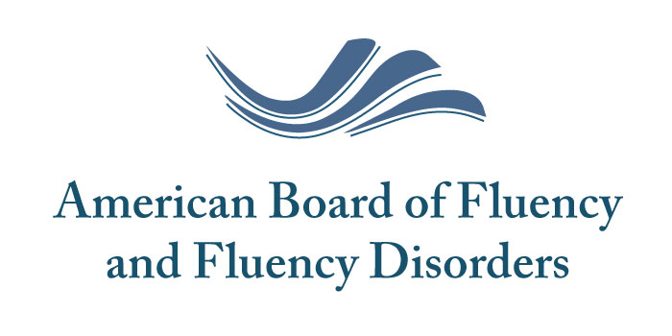
Board Certified Specialist-Fluency and Fluency Disorders
FIVE-YEAR RENEWAL CONTINUING EDUCATION FORM
Please complete the following form, request your official CE transcript from ASHA, and attach it to this form prior to sending it to the address listed at the top of this form.
Name:  Organization: | Professional Address:  City, State, Zip Code:
Home Address:  City, State, Zip Code: | Daytime Phone:  Email:  Website:  ASHA #:

Continuing Education Parameters for BCS-F Application:
- Documentation of 10 CEUs (100 contact hours) over the 5-year renewal period in the area of specialty certification. Continuing Education must be at the Intermediate or Advanced Level.

- Continuing Education must be from a variety of sources (direct participation in conferences/workshops; Journals; DVDs; Web-based CEUs). Additionally, at least half (5 CEUs, 50 hours) of your CE activity should be derived from live events. Live CE events can be attended in-person or online. DVDs, prerecorded trainings/workshops, and journal article self-study CEs are all considered non-live.

- Continuing Education must come from a variety of topics (80 hours must come from topics specifically related to Fluency and Fluency Disorders; 20 hours from other topics related to diagnosing and treating fluency disorders (e.g., speech, language, motor learning, cognitive, behavioral therapy, sensory processing, executive functioning, autism, counseling, other related disorders).

- Please be sure to scroll to the last page to include your totaled hours in each category

BCS-F FIVE-YEAR RENEWAL CONTINUING EDUCATION ACTIVITY
Date & Name of CE Activity | Number of  Contact Hours | Level:  Intermediate or Advanced | Source:  Conference, DVD, Journal, or Web-based | Mode:  In-Person Live, Online Live, Online Recorded, or Self-Study | Topic:  Fluency Disorders or Related

BCS-F FIVE-YEAR RENEWAL CONTINUING EDUCATION ACTIVITY
Date & Name of CE Activity | Number of  Contact Hours | Level:  Intermediate or Advanced | Source:  Conference, DVD, Journal, or Web-based | Mode:  In-Person Live, Online Live, Online Recorded, or Self-Study | Topic:  Fluency Disorders or Related

BCS-F FIVE-YEAR RENEWAL CONTINUING EDUCATION ACTIVITY
Date & Name of CE Activity | Number of  Contact Hours | Level:  Intermediate or Advanced | Source:  Conference, DVD, Journal, or Web-based | Mode:  In-Person Live, Online Live, Online Recorded, or Self-Study | Topic:  Fluency Disorders or Related

Totals
Live CEUs (at least 50 hours)
Non-Live CEUs
CEUs directly related to Fluency and Fluency Disorders (at least 80 hours)
Other Related CEUs
Total CEUs (at least 100 hours)

